Name
Professor
Title
Date

Research on Global Warming and Climate Change
Abstract
Introduction
With the widespread industrialization, atmospheric pollution continues to occur with release of hazardous gases. These hazards include dusts, carbon-containing fumes, and flammable gases, which continually deplete the ozone layer, have a great impact in causing global warming.
With the increase in human activities on the planet, there is need for protection of the environment. This entails conservation of the natural resources in order to preserve ecosystems and sustain human life. Pollution is growing as a huge threat to natural processes such as precipitation and has resulted into adverse effects such as global warming. Protecting the environment pertains to the activities that humans have taken in addressing pollution and exploitation of natural resources in order to create sustainable social and economic systems. To harmonize the concerns about the environment and human interrelationships, the international community together with the local governments has set out standards to direct conservation efforts. These methods include creation of awareness through education of communities, setting up of legal measures, technological interventions and adoption of alternative means of energy.
Objectives
The main objective is to highlight the importance of recognizing the fact that global warming exists and underscore the possible measures to mitigate the process.
Methodology
The area of study includes the entire globe with focus on the climatic changes that have occurred in the recent years in the United States. The sources of data include data from Gallup; an American research-based company that deals with opinion polls. Thus, the research makes use of secondary sources to a great extent. Tables and graphs are used to analyze the data herein.
Results
The research found out that global warming is a subject matter of concern and about 70 % of the US population believe that global warming is influenced by human activities. The causes of global warming are very familiar to us. These include the present and past emissions, methane gases released by fossils, among others. The government has a special role in the mitigation process. Depending on the members of the congress’ view, the government will consider channeling resources towards mitigation of the same.
Recommendations
We should look beyond the protocols and acts that litigate the global warming process and save our environment from unnecessary changes that will be a threat to most species on the entire earth surface.
The government should use resources wisely so that it does not close an eye on the more pressing issues in favor of mitigating and litigating global warming and climate change.
Background Information
The increase in the cases of natural calamities such as hurricanes, drought and skin diseases is a clear indication that global warming and climate change is real. For instance, the increase in the duration of drought in California is worrying. Research has indicated that the overall surface runoff and precipitation in California has been on the decline for the past 14 years (Mann & Gleick 13). Dow and Downing have indicated that present and past emissions have contributed significantly towards global warming. For instance, emissions sparked during ploughing, from industries, and methane released by animals increase the green-house gases to a great extent (Dow & Downing 14).
The thought that time is running out to save the globe from the green-house effect is troublesome. However, there are issues of concern that need clarifications in order to move in unison to prevent the looming menace. For instance, is this climate change and global warming really important? Most would argue that man has really a very limited role to control nature (Fyfe 224). The emissions from erupted and currently erupting volcanoes are said to be the main causes of global warming for which humans have no control over.
The effects of climate change and global warming are clear. To begin with, many species may fail to adapt to the new changes in climate and fall into extinction. It is not obvious that the human species will adapt to the climate change and global warming effect (Magozzi, Sarah, and Piero 181). The human species may, hence, perish altogether due to food and water insecurity and possible outbreak of diseases from a new set of microorganisms that have adapted to the new changes.
Justification
The existence of ideological difference over the issue of climate change and global warming calls for a vivid clarification on the present trends, litigations, and mitigations on the topic at hand. With a clearer view of this topic, we will be in a position to understand the need to act in unison to prevent global warming and climate change to a greater extent.
Objectives
The main objective is to highlight the importance of recognizing the fact that global warming exists and underscore the possible measures to mitigate the process.
To assess the amount of resources that would be used to curb global warming and climate change without shifting concentration from more pressing issues that bedevil mankind.
To determine the possible causes of global warming and climate change.
To assess whether our country has a role to play in terms of preventing global warming and climate change.
To determine the measures available to slow down the global warming process and the role the US government can take to prevent the entire process.
Literature Review
Elsner et al conclude that hurricane intensity is on the rise and is likely to increase in this era of increasing global temperatures. The atmospheric temperature has a direct relationship with the humidity and the potential energy for formation of hurricanes. At present, high temperatures continue to cause devastating effects on the polar glaciers. Increased melting of ice on mountains and temperate countries eventually leads to a rise in the sea level. This is a positive predictor of occurrence of ocean related hazards such as hurricanes and tsunamis (Smith 78).
Royal National Park of 2013 advocates for enactment of legislations such as the Kyoto Protocol of 2010 has made many countries abide to the laws of environmental conservation. For instance, international laws protects the endangered tree and animal species. The United Nations Environmental Program has played a major role in environmental conservation. The UNEP has signed legislative agreement with many a countries to ensure people respect environmental conservation (Dauvergne 127).
Methodology
The research focusses on the whole globe as the study area. However, most statistics is on the United States. A convenient sampling method is used to highlight issues that would answer the objective questions such as the views made by the democrats and republicans on global warming. Data analysis is through tables, graphs, pie charts, and flow charts.
Study Limitation
It was difficult to use case control studies and make experiments on climate change and global warming. Most data is hence secondary data.
Results
Most of the following data is from Gallup, an organization entrusted in research on global warming and its effects.
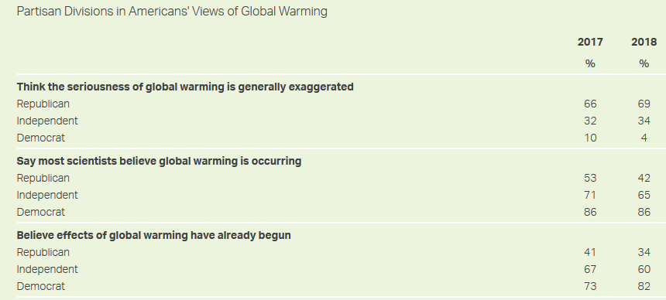
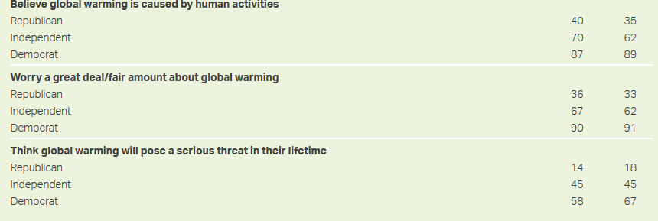
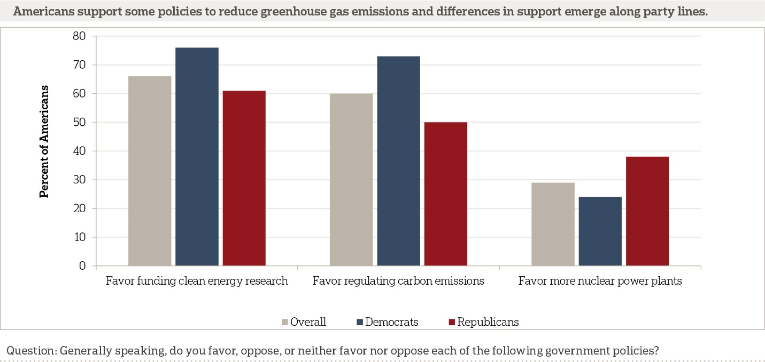
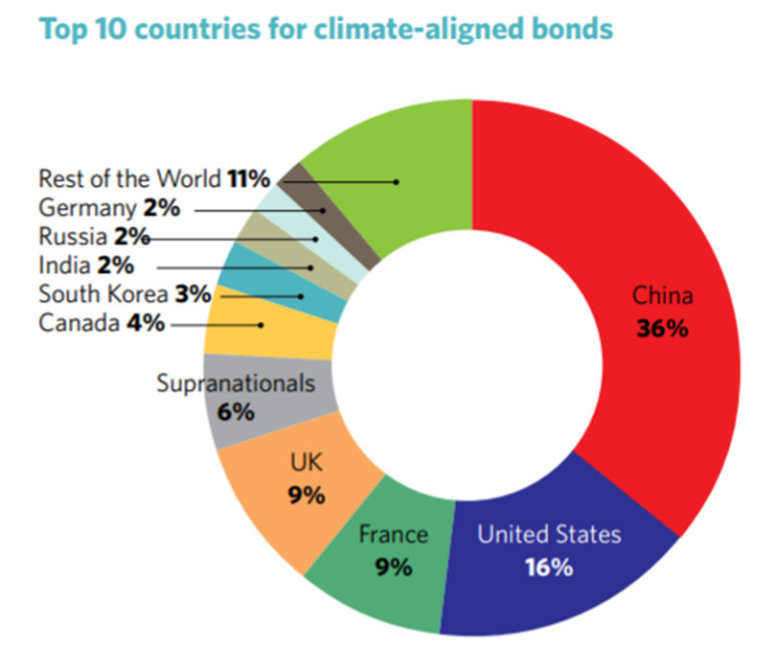
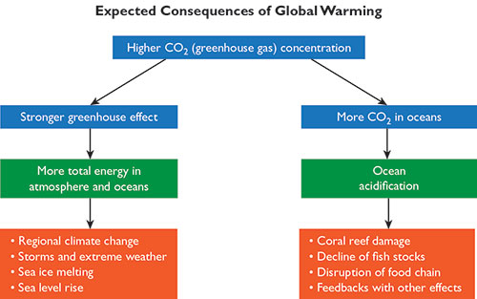

Interpretation
From the above data, it is clear that the Republicans think that global-warming is non-existing. Thus, it proves difficult for the Federal Government to allocate sufficient resources to curb the menace. The percentage of Republicans who believe that the effects of global warming is at 69 % by 2018.
The United States ranks second in terms of attention and resource allocation to different parts issues that promote emission of green-house gases.
The available regulations for global warming include funding of energy research that would precipitate clean sources of energy, reduction of emissions from the Earth’s surface.
The effects of global warming mainly entail changes in the ecosystem which ultimately forces most species to either adapt to the new changes or get extinct.
Mitigations on global warming and climate change, such as the Kyoto Protocol, have been enacted to reinforce the need to conserve and preserve the environment.
Discussion
It is with regret that the US president, in conjunction with his party members, believe that global warming and its effects have been exaggerated significantly. It so follows that the Federal Government may not take much interest into funding the current efforts to champion further interventions against global warming (Dunlap and McCright 26). However, the fact that a higher percentage of independent individuals and Democrats believe that global warming has already begun gives more hope for the fight against the looming menace.
The effects of global warming are real. Down and Downing indicate that already “many species and ecosystems may not be able to adapt to new climatic conditions and stress”. Currently, the climatic changes in California evidenced by increased episodes of draught and the general decline in the amounts of precipitation and surface runoff is a clear indication that climate change is here with us (Dow and Downing 57). The melting of ice will lead to a substantive rise of the sea level. As such, the coastal communities will be compelled to vacate their premises. Furthermore, the disruption of coral reefs will significantly reduce the population of sea creatures.
Environmental protection entails limiting the pollution effects and exploitation of resources such as water, soil and the atmosphere. Control and safe disposal of wastes to these resources that make up the biosphere is significant in the quest of prevention of extinction of various species. The atmosphere harbors the gases essential for support of life. Conservation of the atmosphere aims at limiting the pollution effects of carbon containing gases, radioactive emissions, dust and noise (Smith & Taylor, 112). Chemical emissions from industries, agricultural activities and smoke also form the sources of air pollution.
Limiting the effects of exhaustion of land resources due to construction of human made structures such as cities, highways and railway lines is a target for environmental conservation efforts. This links with the preservation of land resources during large scale-reclamation from the huge water bodies. The issue of environmental protection is thus safeguarding resource utilization with the aim of protecting against their exhaustion (Cook et al. 77). Measures to prevent pollution of land also include forest preservation, control of desertification, rational use of land in terms of regulation of populations, and proper planning of urban centers.
To reduce the use of fossil fuel, environmental conservation has steered towards adoption of renewable and sustainable sources of energy. Alternative energy comprises of the renewable sources of power that do not produce carbon emissions. This type of energy is easily to replenish. The main components of this form of energy include biomass, wind energy, solar energy, geothermal power and the more recent nuclear power. The generation of this power does not result into release of carbon as an end-product thus minimal pollution effects. Carbon discharges emanating from burning of fossil fuels has a link with the “Greenhouse Effect” also known as global warming (Smith & Taylor, 111).
International laws have regulated waste disposal from industries. Currently, treatment of waste is a prerequisite before release into rivers. In addition, the UNEP controls the emission of fumes from motor vehicle by setting the international emission limits. The Volkswagen brand has a court case following diesel emission of the products from VW were beyond the international limits. Apparently, the company had made a software that made it possible to conceal some emissions, which in real sense were up to 40 times the global limit (Blackman 20).
Conclusion and Recommendations
Global warming and climate change is, indeed, real. The US Government has a significant role to play in terms of uniting with other signatories of various acts and protocols to support the fight against climate change and green-house effect.
Mitigation aims at reducing the environmental effects of greenhouse gases in the quest of combating climate. Mitigation measures to curb storms serves as a better approach as it anticipates the problem and action to prevent it take effect during mitigation. This process is of much benefit, even for the future generations, apart from the fact that there are cost implications if full implementation of mitigation approaches occurs.

Work Cited
Mann, Michael E., and Peter H. Gleick. "Climate change and California drought in the 21st century." Proceedings of the National Academy of Sciences 112.13 (2015): 3858-3859.
Dunlap, Riley E., and Araon M. McCright. "A widening gap: Republican and Democratic views on climate change." Environment: Science and Policy for Sustainable Development 50.5 (2008): 26-35.
Kristin Dow and Thomas Downing. The Atlas of Climate Change: Mapping the World's Greatest Challenge. Univ of California Press, 2016
Smith, K. Environmental Hazards: Assessing Risk and Reducing Disaster. New York: Sixth Edition, Routledge (2013).
Royal National Park. NSW Office of Environment and Heritage. Royal National Park Publishers (2013).
Blackman, R. Can Environmental Regulation work in developing countries? Policy Studies Journal. (2015) 15 (2):17-34.

Smith Z. & Taylor K., Renewable and Alternative Energy Resources: A Reference Handbook. New York, NY: ABC-CLIO (2015).
Cook, John, et al. "Consensus on consensus: a synthesis of consensus estimates on human-caused global warming." Environmental Research Letters 11.4 (2016): 048002.
Fyfe, John C., et al. "Making sense of the early-2000s warming slowdown." Nature Climate Change 6.3 (2016): 224.
Magozzi, Sarah, and Piero Calosi. "Integrating metabolic performance, thermal tolerance, and plasticity enables for more accurate predictions on species vulnerability to acute and chronic effects of global warming." Global change biology 21.1 (2015): 181-194.
Dauvergne, Peter. Historical dictionary of environmentalism. Rowman & Littlefield, 2016.

